**Sales order service for Sales Line Rep**

1. **Run IIS manager and find the MicrosoftDynamicsAif50 site and explore its file and make a backup of entire files. Also you need to stop WWW service.**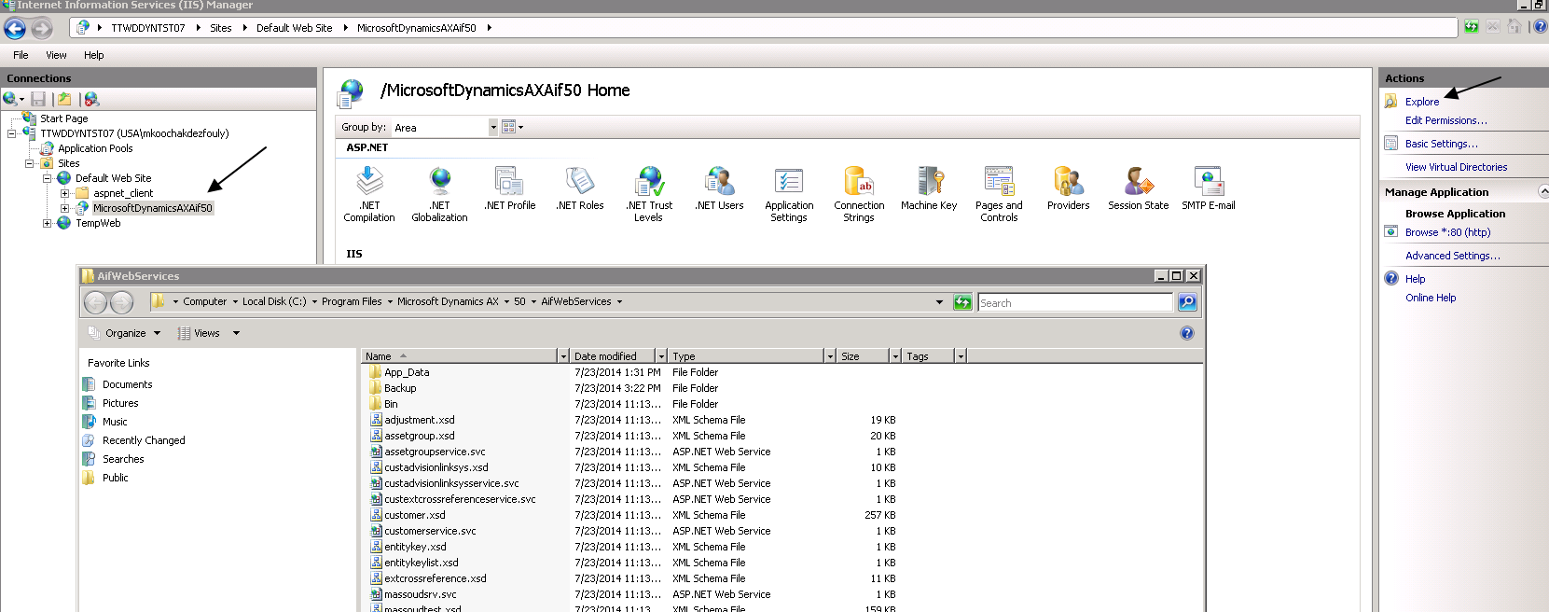

**[Step 2 and 3 are only for deploying to STAGE not PROD).**

1. **Import AX project JIRA_PEAX_CO. Then find the project in AX projects and compile it again to make sure there is no error.**
2. **Some AX objects in the AX project needs to be updated cross reference. To do that you need right click on object and do as below screen shot. Objects are : SalesLineType - xSalesLineRe-**

**AxdSalesOrder** 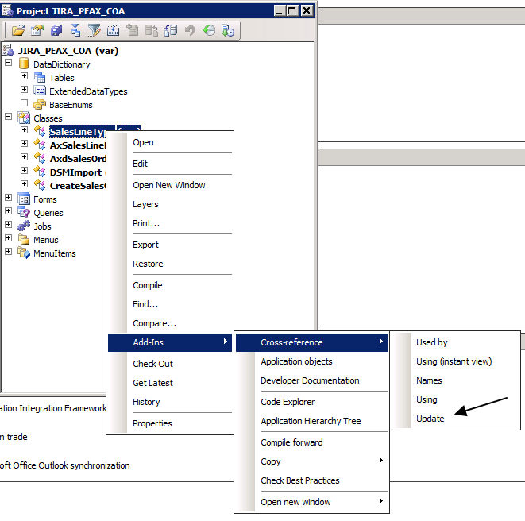

1. **Now the AIF service needs to be updated. Run AX tools->development tools->Application Integration Framework->update document service.** 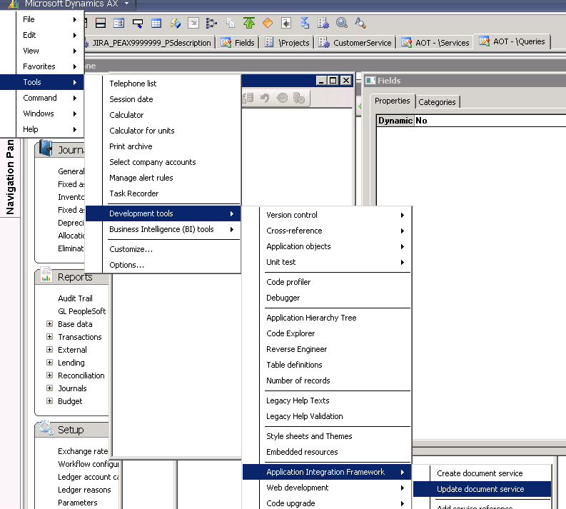
2. **In update service form you need to specify SalesSalesOrderService as below and click OK: (make sure 2 check boxes in bottom of form are selected)**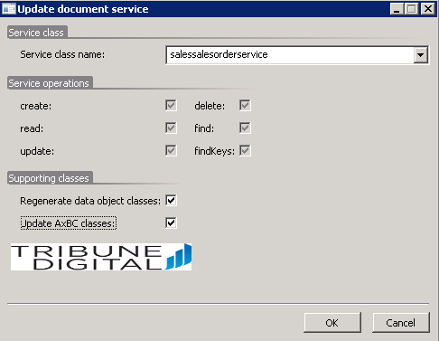

**From this step you need to repeat all below steps for all BU(companies). From top menu select a company**

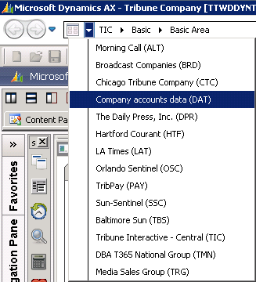

1. **You need to run job AifDataPolicy_SalesSalesOrder in the AX project JIRA_PEAX_COA. You should not get any error when you run the job.**
2. **In AX->Basic->setup-> Application Integration Framework->endpoint form and click on Action Policy button, find SalesSalesOrderService* as below. We should have 6 different actions for this service and only delete and findkey actions should have selected “Is default policy” check box. Keep this form open for another step.**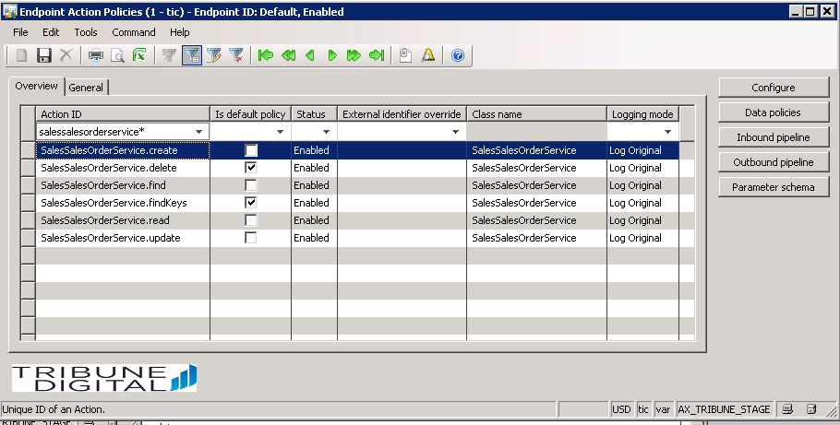
3. **Click on data policy button on above form(Endpoint action policies) to see below form and make sure All fields for SalesLineRep are checked as below, if not then run the job AifDataPolicy_SalesSalesOrder in the AX project JIRA_PEAX_COA**

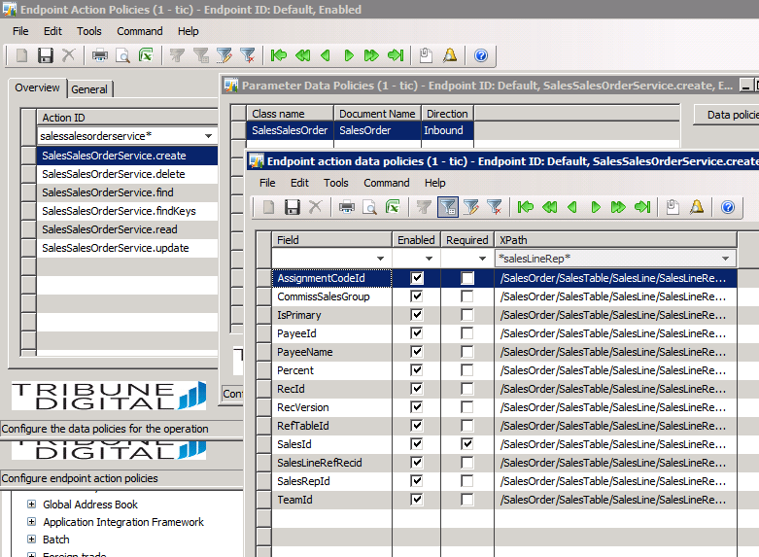

1. **Back to step 6 for another company(BU) but make sure to close all forms in AX otherwise it is hard to switch between companies.**
2. **Go to AX->Basic->setup-> Application Integration Framework->services and find the service as below and click configure button. It should be same as below screen, if it is not change the binding as below:** 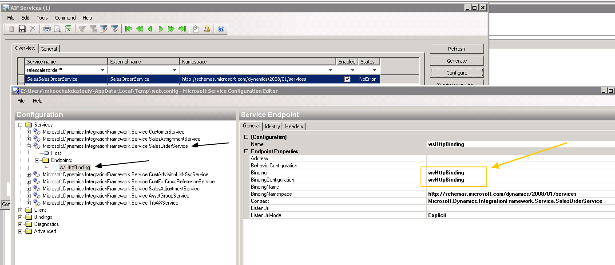
3. **Go to AX->Basic->setup-> Application Integration Framework->services and find the service as below and click generate button to generate IIS service files.** 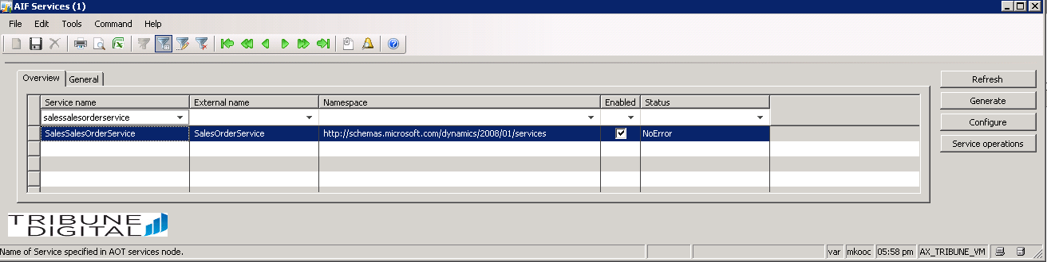

**13- In AX->Basic->setup->Application Integration Framework->web sites shows the MSMQ servers. (Below is from my AX QA and is not same as STAGE or PROD).**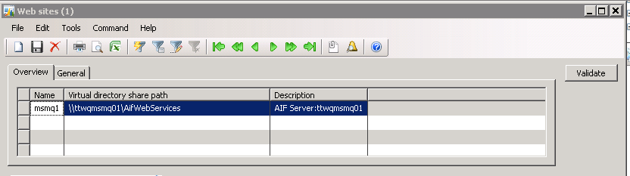

**Now all IIS files(in MSMQ servers) should be updated for services, to check that you need to back to IIS files (step 1) and make sure the files are updated with deployment date if not, means generate service in last step did not work and you need to redo it. If all is correct then you need to restore web.config from backup. Restart WWW services.**

**Start MSMQ AOS service(s).**

**14- Copy AIFTest.exe file from \\xen02\AXFiles\AIF Smoke Test\QA1 LB to the smoke test folder regard to AX env you are deploying(Stage or Prod).**

**Now is time to run SmokeTest. First try to create a new sales order for each BU(company) without error**

**15- Continue to run smoke test for quick test option (QT) to check other services.**